PROGRAMMING LANGUAGE EVALUATION AND APPLICATION SUITABILITY SYSTEM
Submitted by:
JEODY LAINE E. SAEZ
RACHEL JACOB
BSCS – 3A2

Submitted to:
MR. RENO CAGULA
Programming Languages Instructor



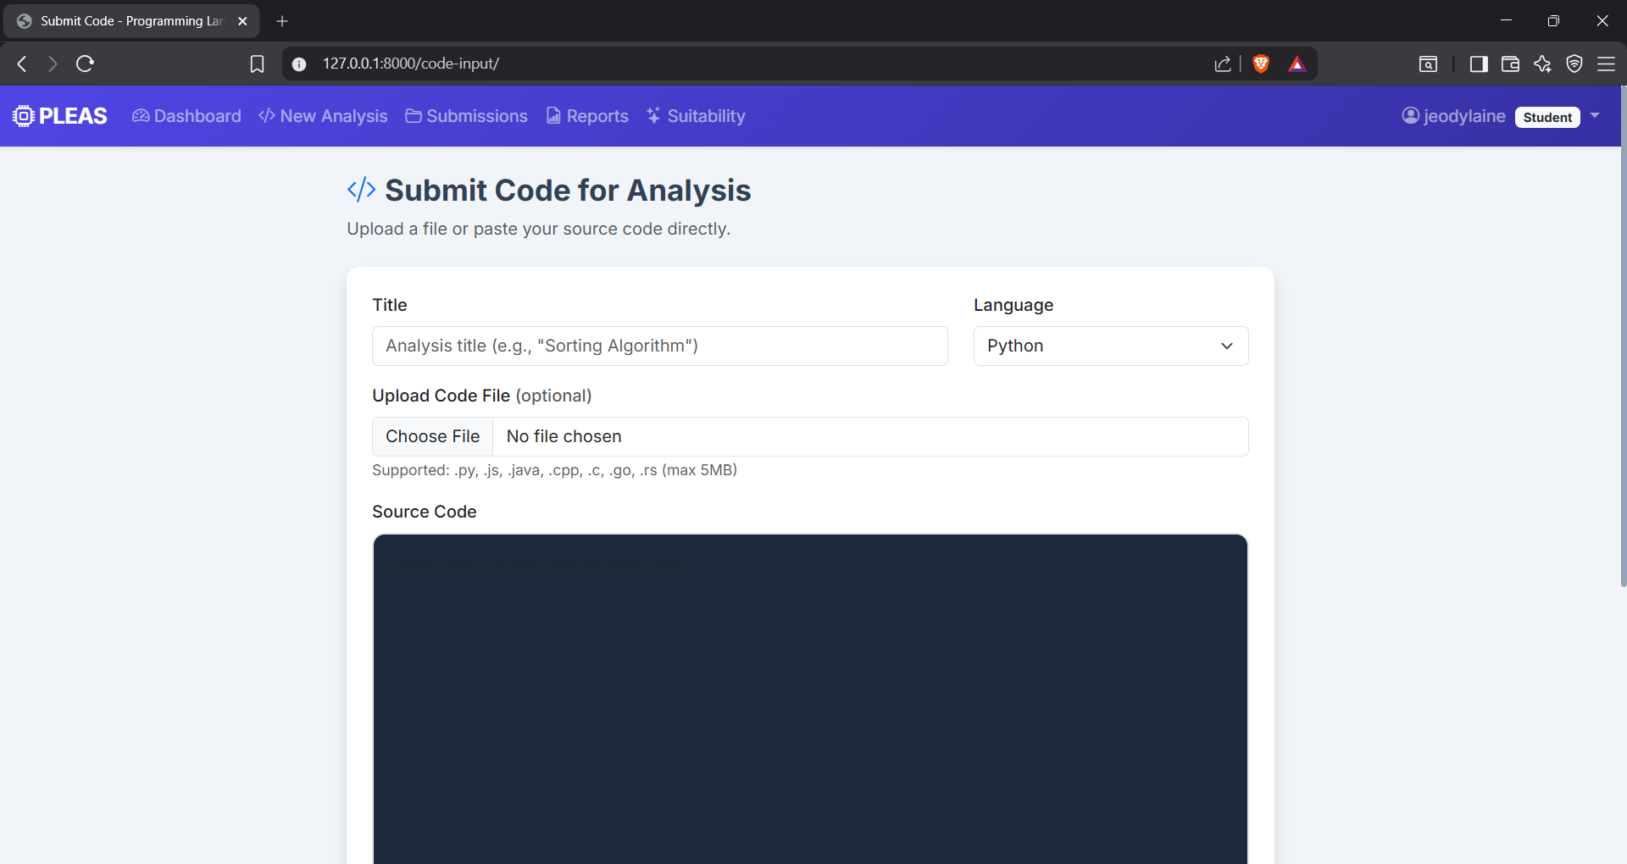


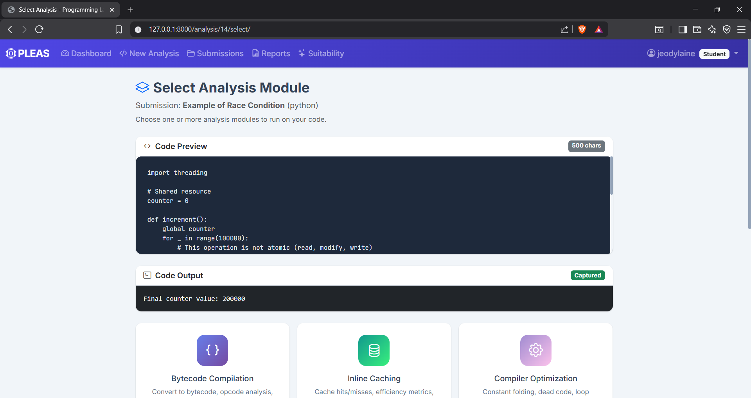



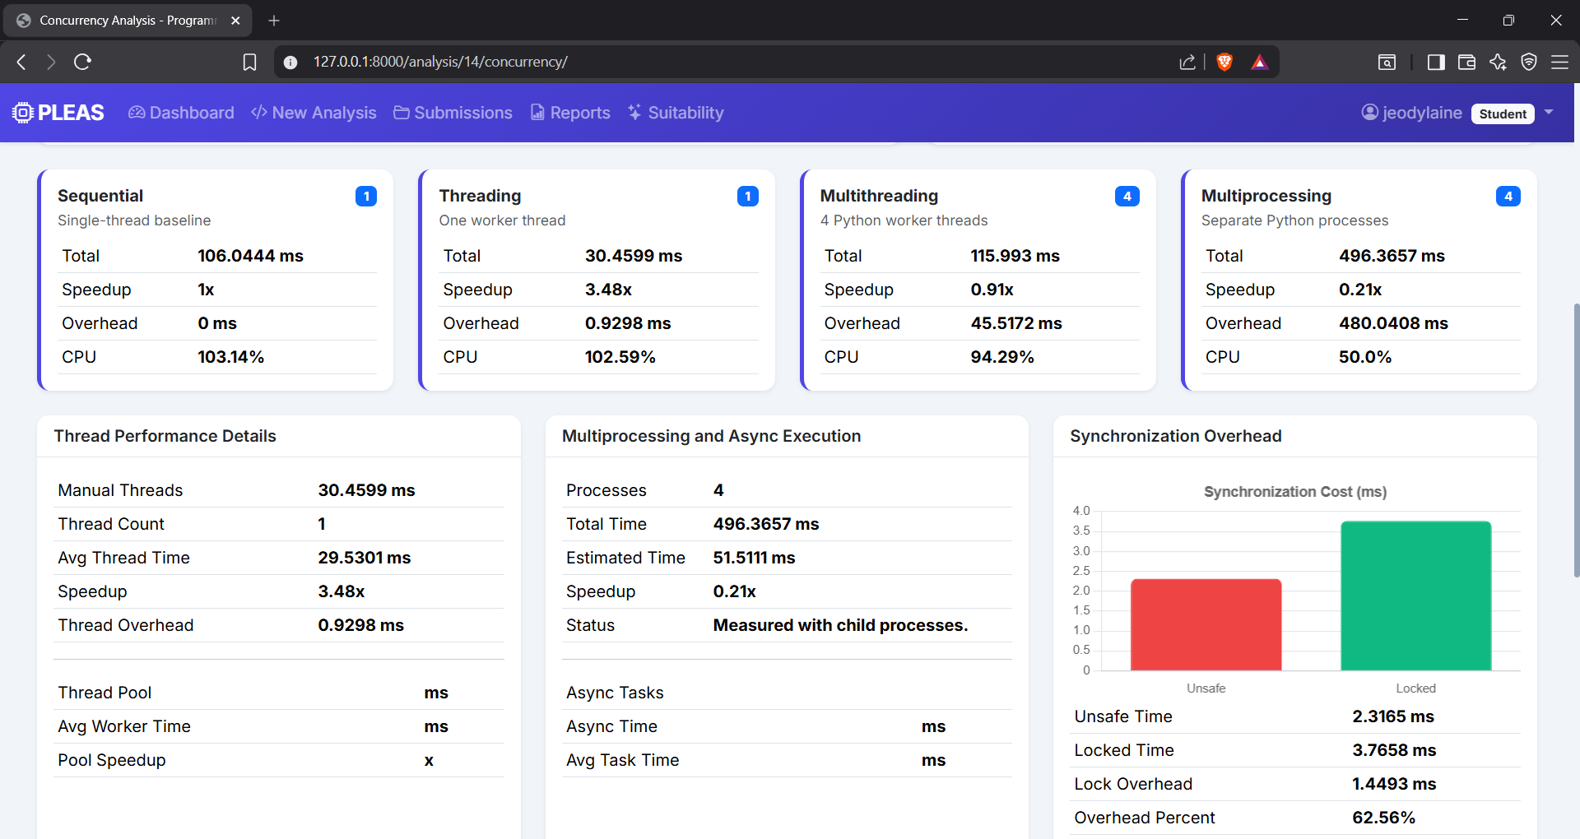
Based on the code snippet:
import threading
counter = 0
def increment():
global counter
for _ in range(100000):
counter += 1

this is a CPU-bound task involving repeated increments of a shared variable. In CPython, the Global Interpreter Lock (GIL) prevents multiple threads from executing Python bytecode simultaneously, which greatly affects threading and multithreading performance.

Interpretation of Your Results
Approach | Total Time | Speedup | Analysis
Sequential | 123.3676 ms | 1.00× | Baseline execution using a single thread.
Threading (1 Worker) | 32.1809 ms | 3.83× | This is unusually faster than the sequential baseline. Most likely, the benchmark framework introduced measurement differences, caching effects, or the workload was not identical. A single thread should generally perform similarly to sequential execution.
Multithreading (4 Threads) | 130.1221 ms | 0.95× | Slightly slower than sequential because the threads compete for the GIL. Since the task is CPU-bound, multiple Python threads cannot execute the increment operation in parallel. Thread management overhead increases execution time.
Multiprocessing (4 Processes) | 663.9726 ms | 0.19× | Much slower because the workload is too small to justify creating and managing separate processes. Process startup, memory allocation, and inter-process communication overhead dominate the actual computation time.

During the project presentation held on May 28, 2026, the chairman of the panel, Mr. Reno Cagula, suggested the removal of the card that calculates the efficiency of the code when thread pool and asynchronous processing were applied. This recommendation was made because these concepts, specifically thread pool execution and async programming, were not part of the course coverage and were not thoroughly discussed in the Programming Language Evaluation class. Therefore, their inclusion in the performance comparison was deemed outside the scope of the study. Even with the removal of that evaluation component, the results still demonstrate that multithreading does not improve performance for CPU-bound operations involving shared variables in Python due to the Global Interpreter Lock (GIL). Although multiprocessing can achieve true parallel execution, the computational workload in this experiment was too small to compensate for process creation and communication overhead. Consequently, sequential execution remained competitive, while multiprocessing exhibited the poorest performance. These findings highlight the importance of selecting an appropriate concurrency model based on workload characteristics and execution overhead.

